<https://www.youtube.com/watch?v=2U9eVClAqh0>

<https://www.youtube.com/watch?v=Stw-WAUNNYM>

<https://codesandbox.io/s/25nbi?file=/App.tsx:492-588>

<https://table-react-component.vercel.app/demo/title-and-footer>

<https://www.varvet.com/blog/format-numbers-in-input-fields-using-react/>

|  |
| --- |
| Changement d’Icone Delete  Dans le répertoire  C:\scaffoldhub.io\FusionXV4.2\frontend\node\_modules\@material-ui\icons  Copier Save.js en dlete.js pour changer l’icone de delete en icone de save. |
| Change in C:\scaffoldhub.io\FusionXV4.2\frontend\src\i18n\en.tsx   * Delete by Act\_On * delete by acte |

Backend

Go to the **backend folder**

npm install

/////////SET .ENV///////////

DATABASE\_USERNAME = "root"

DATABASE\_DIALECT = "mysql"

DATABASE\_PASSWORD = "123"

DATABASE\_DATABASE = "fusionx"

DATABASE\_HOST = "localhost"

DATABASE\_LOGGING = "true"

////////////////////

this.currentUserRolesIds.some is not a function

|  |  |
| --- | --- |
| **Amend** C:\scaffoldhub.io\fx2\backend\  src\services\user\permissionChecker.ts | /\*\*  \* Checks if the current user roles allows the permission.  \*/  hasRolePermission(permission) {  **return true;**  /\*\* return this.currentUserRolesIds.some((role) =>  permission.allowedRoles.some(  (allowedRole) => allowedRole === role,  ),  ); \*/  } |
| **Solution**  [**https://githubmemory.com/repo/scaffoldhub/issues/issues/28**](https://githubmemory.com/repo/scaffoldhub/issues/issues/28)  **Remplacer dans (**C:\scaffoldhub.io\FusionXV4.2\backend\src\database\models\tenantUser.ts  **)**  validate: {…}  **Par**  get: **function** () {  *// @ts-ignore*  **return** this.getDataValue('roles')  ? *// @ts-ignore*  JSON.parse(this.getDataValue('roles'))  : null;  }, | roles: {          type: SequelizeArrayUtils.DataType,          get: function () {            // @ts-ignore            return this.getDataValue('roles')              ? // @ts-ignore                JSON.parse(this.getDataValue('roles'))              : null;          },          // validate: {          //   isValidOption: function (value) {          //     if (!value || !value.length) {          //       return value;          //     }            //     const validOptions: any = Object.keys(Roles.values);            //     if (          //       value.some(          //         (item) => !validOptions.includes(item),          //       )          //     ) {          //       throw new Error(          //         `${value} is not a valid option`,          //       );          //     }            //     return value;          //   },          // },        }, |

Ou/ Copier

De:

C:\scaffoldhub.io\Reset Files\tenantUser.ts

C:\scaffoldhub.io\Reset Files\.env

A :

C:\scaffoldhub.io\FusionXV4.2\backend\src\database\models\tenantUser.ts

C:\scaffoldhub.io\FusionXV4.2\backend\.env

npm run db:create

npm start

Frontend

Go to the **backend folder**

npm install

npx browserslist@latest --update-db

npm start

C:\scaffoldhub.io\FusionX V2\backend\src\services\chequeService.ts

C:\scaffoldhub.io\FusionX V2\backend\src\services\chequeService.ts

|  |
| --- |
| async findAndCountAll(args) {      args.filter={        ...args.filter,        numeroBordereau: "8a3aaafd-f803-4581-8bb9-e53f5574b4ae",      };      return ChequeRepository.findAndCountAll(        args,        this.options,      );    } |
| C:\scaffoldhub.io\FusionX V2\backend\src\database\repositories\bordereauRepository.ts  // MGBANET      const record = await options.database.bordereau.create(        {          ...lodash.pick(data, [            'numBordereau',            'rIBBeneficiaire',            'montant',            'nombreValeur',            'nomBeneficiaire',            'stepFLow',            'importHash',          ]),          numBordereau: "BD",          tenantId: tenant.id,          createdById: currentUser.id,          updatedById: currentUser.id,        },        {          transaction,        },      ); |

|  |
| --- |
| import { Table, Popconfirm } from 'antd';  import { i18n } from 'src/i18n';  import actions from 'src/modules/cheque/list/chequeListActions';  import destroyActions from 'src/modules/cheque/destroy/chequeDestroyActions';  import selectors from 'src/modules/cheque/list/chequeListSelectors';  import destroySelectors from 'src/modules/cheque/destroy/chequeDestroySelectors';  import chequeSelectors from 'src/modules/cheque/chequeSelectors';  import React from 'react';  import { useSelector, useDispatch } from 'react-redux';  import { Link } from 'react-router-dom';  import TableWrapper from 'src/view/shared/styles/TableWrapper';  import ButtonLink from 'src/view/shared/styles/ButtonLink';  import moment from 'moment';  import BordereauListItem from 'src/view/bordereau/list/BordereauListItem';  import { toNumber } from 'lodash';  const ChequeListTable = (props) => {    const dispatch = useDispatch();    const findLoading = useSelector(selectors.selectLoading);    const destroyLoading = useSelector(      destroySelectors.selectLoading,    );    const loading = findLoading || destroyLoading;    const rows = useSelector(selectors.selectRows);    const pagination = useSelector(      selectors.selectPagination,    );    const selectedKeys = useSelector(      selectors.selectSelectedKeys,    );    const hasPermissionToEdit = useSelector(      chequeSelectors.selectPermissionToEdit,    );    const hasPermissionToDestroy = useSelector(      chequeSelectors.selectPermissionToDestroy,    );    const handleTableChange = (      pagination,      filters,      sorter,    ) => {      dispatch(        actions.doChangePaginationAndSort(pagination, sorter),      );    };    const doDestroy = (id) => {      dispatch(destroyActions.doDestroy(id));    };    const columns = [      {        title: i18n('entities.cheque.fields.typeOperation'),        sorter: true,        dataIndex: 'typeOperation',      },      {        title: i18n('entities.cheque.fields.referenceOperation'),        sorter: true,        dataIndex: 'referenceOperation',      },      {        title: i18n('entities.cheque.fields.dateCreation'),        sorter: true,        dataIndex: 'dateCreation',        render: (value) =>          value            ? moment(value).format('YYYY-MM-DD HH:mm')            : null,      },      {        title: i18n('entities.cheque.fields.numeroCheque'),        sorter: true,        dataIndex: 'numeroCheque',      },      {        title: i18n('entities.cheque.fields.montantCheque'),        sorter: true,        dataIndex: 'montantCheque',        align: 'right',      },      {        title: i18n('entities.cheque.fields.ribTire'),        sorter: true,        dataIndex: 'ribTire',      },      {        title: i18n('entities.cheque.fields.nomTire'),        sorter: true,        dataIndex: 'nomTire',      },      {        title: i18n('entities.cheque.fields.rIBBeneficiaire'),        sorter: true,        dataIndex: 'rIBBeneficiaire',      },      {        title: i18n('entities.cheque.fields.nomBeneficiaire'),        sorter: true,        dataIndex: 'nomBeneficiaire',      },      {        title: i18n('entities.cheque.fields.numeroBordereau'),        sorter: false,        dataIndex: 'numeroBordereau',        render: (value) => <BordereauListItem value={value} />,      },      {        title: '',        dataIndex: '',        width: '160px',        render: (\_, record) => (          <div className="table-actions">            <Link to={`/cheque/${record.id}`}>              {i18n('common.view')}            </Link>            {hasPermissionToEdit && (              <Link to={`/cheque/${record.id}/edit`}>                {i18n('common.edit')}              </Link>            )}            {hasPermissionToDestroy && (              <Popconfirm                title={i18n('common.areYouSure')}                onConfirm={() => doDestroy(record.id)}                okText={i18n('common.yes')}                cancelText={i18n('common.no')}              >                <ButtonLink>                  {i18n('common.destroy')}                </ButtonLink>              </Popconfirm>            )}          </div>        ),      },    ];    const rowSelection = () => {      return {        selectedRowKeys: selectedKeys,        onChange: (selectedRowKeys) => {          dispatch(actions.doChangeSelected(selectedRowKeys));        },      };    };    //MGBANET    // rows.forEach((item, index) => {    //  item.value = index.montantCheque    //};    var ChqTotal = 0;    rows.forEach(      (item) => {        ChqTotal = ChqTotal + toNumber(item.montantCheque);      });      return (      <TableWrapper>        <Table          rowKey="id"          loading={loading}          columns={columns as any}          dataSource={rows}          pagination={pagination}          onChange={handleTableChange}          rowSelection={rowSelection()}          scroll={{            x: true,          }}          footer={currentData => <div>Footer: {currentData.length} items</div>}          summary={currentData => (            <>              <tr>                <th colSpan={6}>Summary</th>              </tr>              <tr>                <td>-</td>                <td>-</td>                <td>-</td>                <td>{currentData.reduce((total, item) => total + item.value, 0)}</td>                <td> Total Bordereau:  {ChqTotal} </td>              </tr>            </>          )}        />      </TableWrapper >    );  };  export default ChequeListTable; |

# TypeError: this.currentUserRolesIds.some is not a function #28

Hi, i'am try use scaffoldhub with SQLite3, and after open any entity a have error:

SELECT tenant.id, tenant.name, tenant.url, tenant.plan, tenant.planStatus, tenant.planStripeCustomerId, tenant.planUserId, tenant.createdAt, tenant.updatedAt, tenant.deletedAt, tenant.createdById, tenant.updatedById, settings.id AS settings.id, settings.theme AS settings.theme, settings.backgroundImageUrl AS settings.backgroundImageUrl, settings.logoUrl AS settings.logoUrl, settings.createdAt AS settings.createdAt, settings.updatedAt AS settings.updatedAt, settings.deletedAt AS settings.deletedAt, settings.tenantId AS settings.tenantId, settings.createdById AS settings.createdById, settings.updatedById AS settings.updatedById FROM tenants AS tenant LEFT OUTER JOIN settings AS settings ON tenant.id = settings.tenantId AND (settings.deletedAt IS NULL) WHERE (tenant.deletedAt IS NULL AND tenant.id = '48a54628-1e90-4f35-a0c2-6551537a90f1'); TypeError: this.currentUserRolesIds.some is not a function at PermissionChecker.hasRolePermission (/usr/src/web-control-panel/backend/dist/services/user/permissionChecker.js:63:41) at PermissionChecker.has (/usr/src/web-control-panel/backend/dist/services/user/permissionChecker.js:41:21) at PermissionChecker.validateHas (/usr/src/web-control-panel/backend/dist/services/user/permissionChecker.js:26:19) at /usr/src/web-control-panel/backend/dist/api/user/userList.js:21:46 at Generator.next () at /usr/src/web-control-panel/backend/dist/api/user/userList.js:8:71 at new Promise () at \_\_awaiter (/usr/src/web-control-panel/backend/dist/api/user/userList.js:4:12) at exports.default (/usr/src/web-control-panel/backend/dist/api/user/userList.js:19:33) at Layer.handle [as handle\_request] (/usr/src/web-control-panel/backend/node\_modules/express/lib/router/layer.js:95:5)

[[](https://githubmemory.com/@felipepastorelima)](https://githubmemory.com/@felipepastorelima" \t "_blank)

**felipepastorelima**

[**felipepastorelima**](https://githubmemory.com/@felipepastorelima)CONTRIBUTOR

**Created 3 months ago**

[@ruslan-gennadievich](https://githubmemory.com/@ruslan-gennadievich) SQLite does not have the JSON type and is not supported, but you can add this workaround:

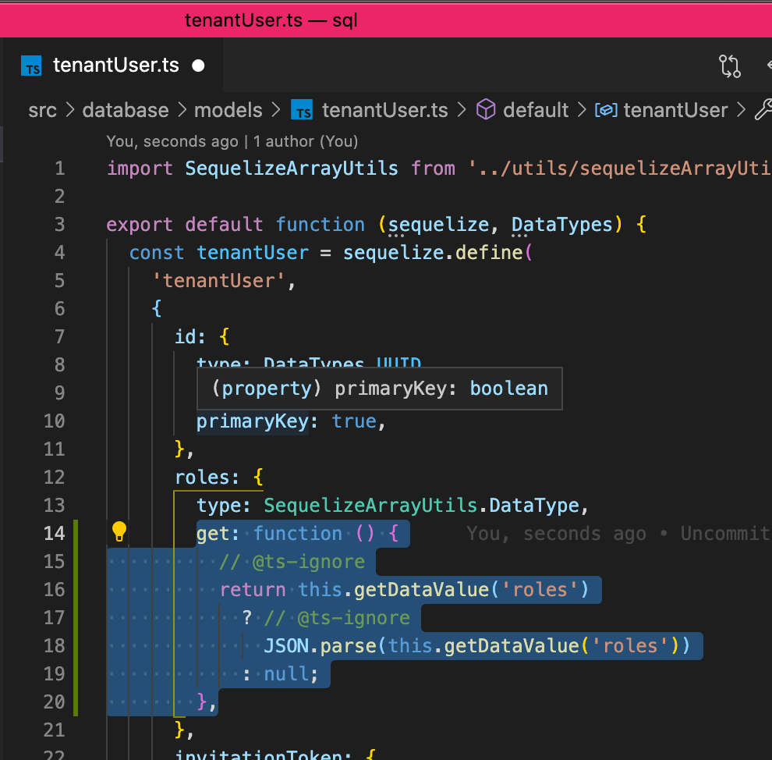

Screen Shot 2021-03-27 at 12 01 16

get: **function** () {

*// @ts-ignore*

**return** this.getDataValue('roles')

? *// @ts-ignore*

JSON.parse(this.getDataValue('roles'))

: null;

},